
Adama Science And Technology University
School of Electrical Engineering and Computing
Department of Computer Science and Engineering

Database
Group Assignment
 | Name | ID | Sec
1. | Gelila Tilahun | UGR/30582/15 | 3
2. | Mohammed Sadik | UGR/30960 /15 | 3
3. | Yonatan Solomon | UGR/31446 /15 | 3
4. | Abigiya Mulugeta | UGR/30088 /15 | 3
5. | Eyasu Tesfaye | UGR/30495 /15 | 3

Submission Date:- 26/Sep/2024G.C
Fikreselam General Hospital

Conceptual ER Diagram

Entities:
- Doctor
  - Attributes: Firstname, Lastname, DoctorID (Primary Key), Password, Description, Status, Email
  - Relationships: Medicates Patients

- Patient
  - Attributes: PatientID (Primary Key), Firstname, Middlename, Lastname, Sex, Birthdate, Nationality, Phone Number, CardNumber, TAT, Age, Address, Photo, BloodGroup, Occupation
  - Relationships: Checked in Lab, Occupies Room, Pays Bills, Medicated by Doctor

- Lab
  - Attributes: LabID (Primary Key), LabNo, LabReport, Date, Category
  - Relationships: Checks Patients, Assigned to Inpatients

- Inpatient
  - Attributes: Firstname, Middlename, Lastname, RoomNumber, DateOfAdmission, BID, Advance, LabNo (Foreign Key)
  - Relationships: Is a type of Patient

- Outpatient
  - Attributes: Firstname, Middlename, Lastname, BID, LabNo, Date
  - Relationships: Is a type of Patient

- Company
  - Attributes: CompanyID (Primary Key), AgreementDate, ExpiryDate, Authorizer, AuthorizedDate, AgreementDescription, InsuranceName, CompanyName, Address, TinNumber, CompanyCode, Discount, PercentValue, PriceDescription
  - Relationships: Provides Terms for Patients

- Bill
  - Attributes: BillNumber (Primary Key), ServiceType, BID, BillDescription, Quantity, DiscountPercent, BillStatus, BillDate
  - Relationships: Issued to Patients

- Room
  - Attributes: RoomName, RoomNumber (Primary Key)
  - Relationships: Occupied by Patients

- Employee
  - Attributes: Firstname, Lastname, Email, PhoneNumber, Address

Relationships:
1. Medicates: One doctor can medicate multiple patients, but each patient is medicated by one doctor.
2. Checks: Patients are checked by labs, and each lab can check multiple patients.
3. Occupies: Patients occupy rooms. One room may be occupied by one patient at a time.
4. Issues: Bills are issued to patients before service, linking patients to payments.
5. Provides: Companies provide insurance agreements or discounts to patients.

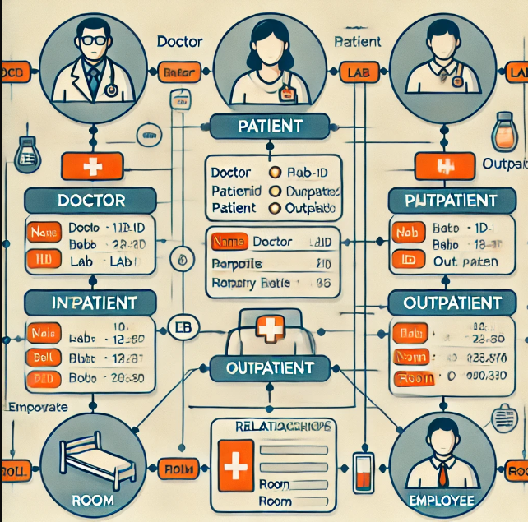

Logical Design ( Relation Schema )
Table Name | Columns | Data Types | Constraints
Doctor | • DoctorID  • Firstname  • Lastname  • Password  • Description  • Status  • Email | INT, VARCHAR, TEXT & UNIQUE | i) PRIMARY KEY (DoctorID)
Patient | • PatientID  • Firstname  • Middlename  • Lastname  • Sex  • Birthdate  • Nationality  • PhoneNumber  • CardNumber  • TAT  • Age  • Address  • Photo  • BloodGroup  • Occupation | INT, VARCHAR , CHAR, DATE ,UNIQUE ,TEXT ,BLOB | i) PRIMARY KEY (PatientID)
Lab | • LabID  • LabNo  • LabReport  • Date  • Category | INT, VARCHAR, DATE, | i) PRIMARY KEY (LabID)
Inpatient | • PatientID  • RoomNumber  • DateOfAdmission  • BID  • Advance  • LabNo | INT, VARCHAR, DATE, DECIMAL. | i) PRIMARY KEY (PatientID)  ii) FOREIGN KEY (PatientID, LabNo)  iii) REFERENCING (PatientID, LabNo)
Outpatient | • PatientID  • BID  • LabNo  • Date | INT, DATE | i) PRIMARY KEY (PatientID)  ii) FOREIGN KEY (PatientID, LabNo)  iii) REFERENCES (PatientID, LabNo )
Company | • CompanyID  • AgreementDate  • ExpiryDate  • Authorizer  • AuthorizedDate  • AgreementDescription  • InsuranceName  • CompanyName  • Address  • TinNumber  • CompanyCode  • Discount  • PercentValue  • PriceDescription | INT, VARCHAR, DATE, TEXT, DECIMAL. | i) PRIMARY KEY (CompanyID)
Bill | • BillNumber  • ServiceType  • BID  • BillDescription  • Quantity  • DiscountPercent  • BillStatus  • BillDate | INT, VARCHAR, TEXT, DECIMAL | i) PRIMARY KEY (BillNumber)  ii) FOREIGN KEY (BID)  iii) REFERENCES (BID)
Room | • RoomName  • RoomNumber | INT, VARCHAR | i) PRIMARY KEY (RoomNumber)
Employee | • Firstname  • Lastname  • Email  • PhoneNumber  • Address | INT, VARCHAR, TEXT, UNIQUE

Relationship Table
Table Name | Coulmns | Data Type | Constriants
Medicates | • DoctorID  • PatientID | INT | i) FOREIGN KEY (DoctorID, PatientID)  ii) REFERENCES (DoctorID, PatientID)
Checks | • LabID  • PatientID | INT | i) FOREIGN KEY (LabID, PatientID)  ii) REFERENCES (LabID, PatientID
Occupies | • RoomNumber  • PatientID | INT | i) FOREIGN KEY (RoomNumber, PatientID)  ii) REFERENCES (RoomNumber, PatientID
Issues | • BillNumber  • PatientID | INT | i) FOREIGN KEY (BillNumber, PatientID)  ii) REFERENCES (BillNumber, PatientID
Provides | • CompanyID)  • PatientID | INT | i) FOREIGN KEY (CompanyID, PatientID)  ii) REFERENCES (CompanyID, PatientID

